EDA LA1

Sachin Kumar and Shivam Kumar

1.Read the csv data file

Spotify data=read.csv (file=file. Choose (), header = TRUE)

2.Display head of data

head (Spotify data)

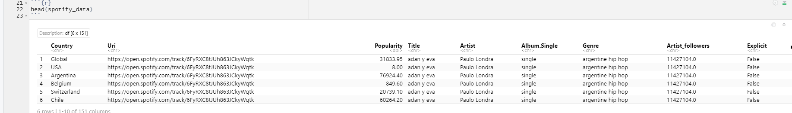

3.Display first n rows specified.

head (spotify_data, n=10)

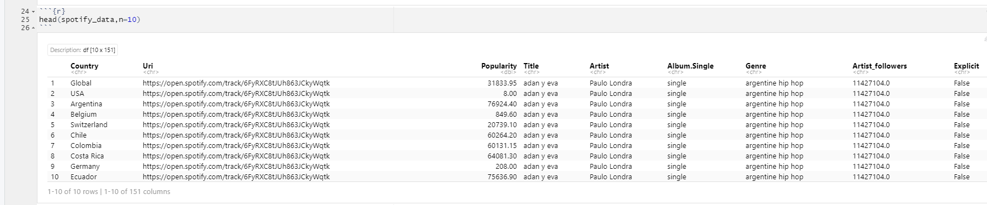

4.Display tail of data.

tail(spotify_data)

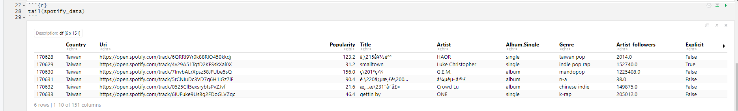

5.Display n rows specified from bottom

tail (spotify_data, n=10)

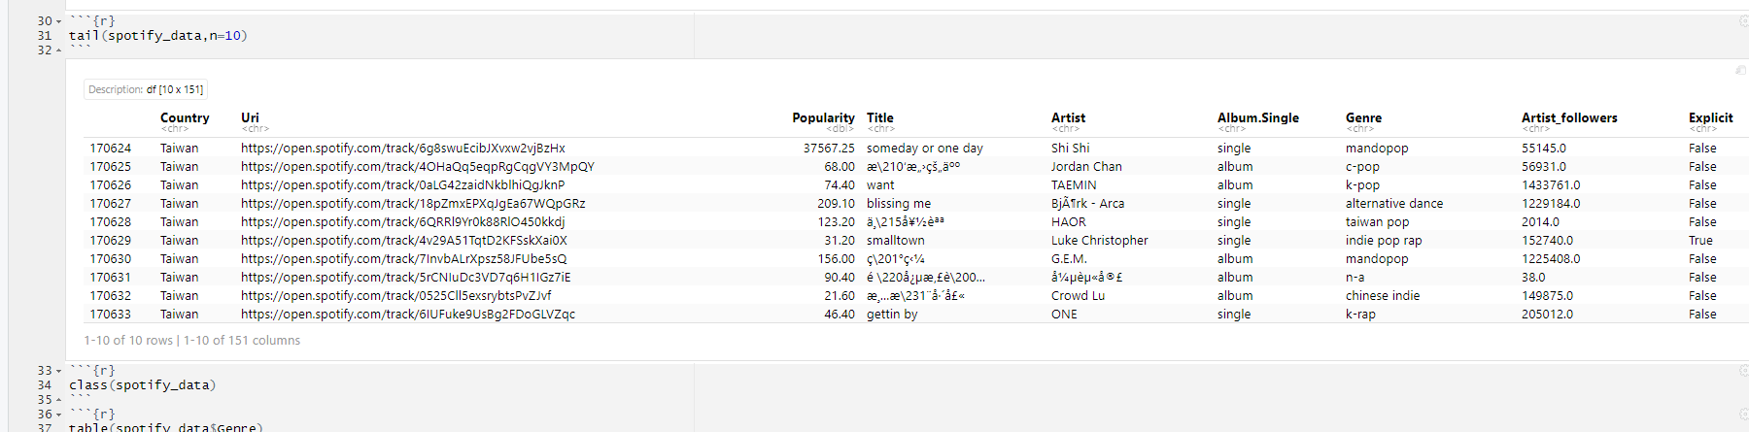

6.Determining Type of data class(spotify_data)

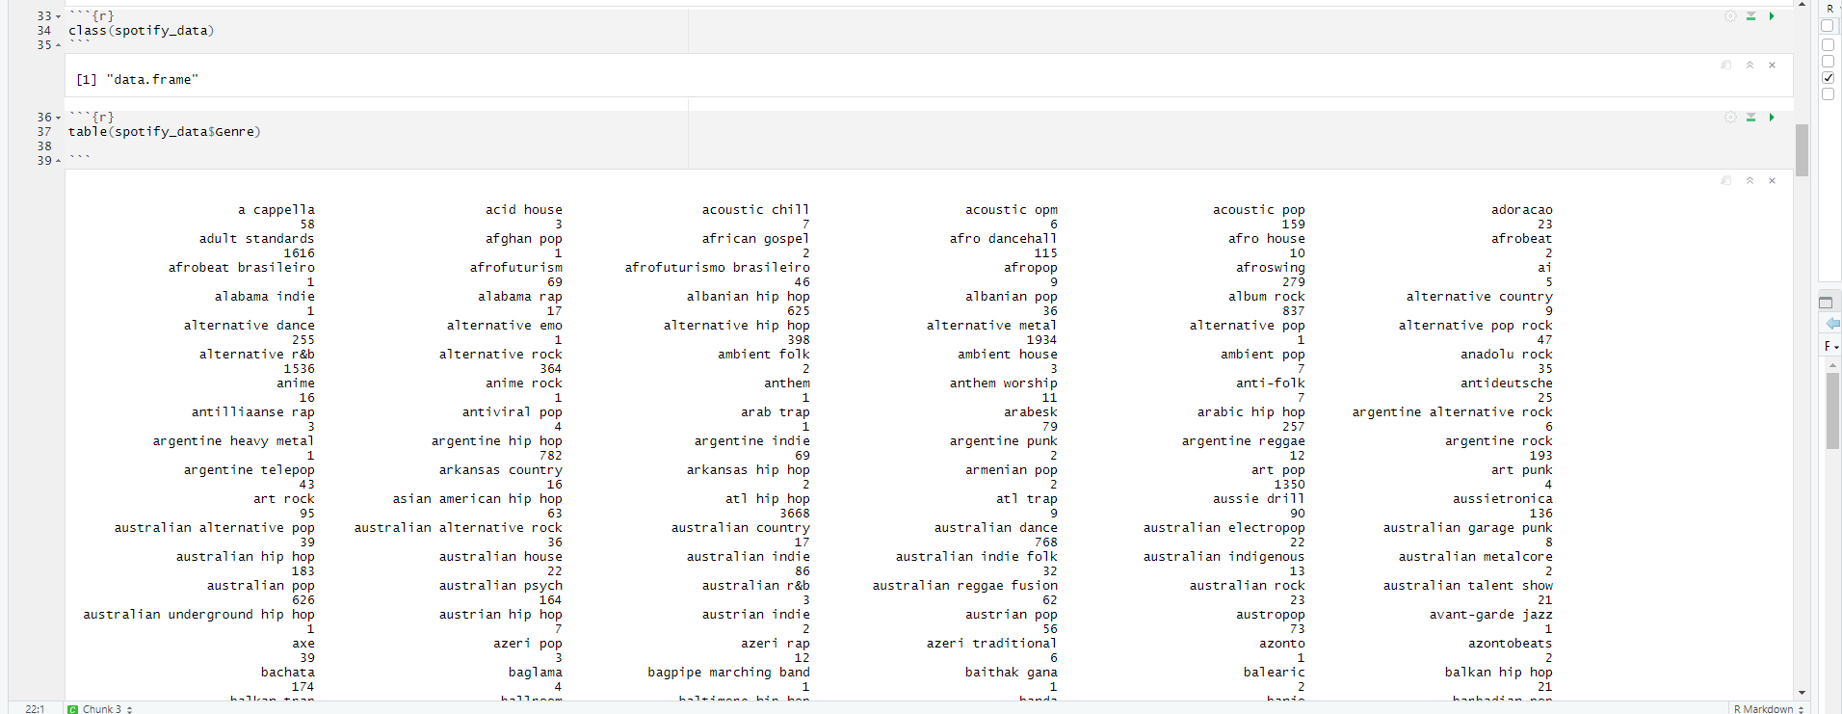

7.Table command table(spotify_data$Genre)

table(spotify_data$Explicit)

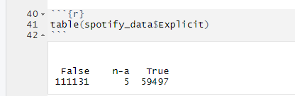

8.Determine the structure of data

str(spotify_data)

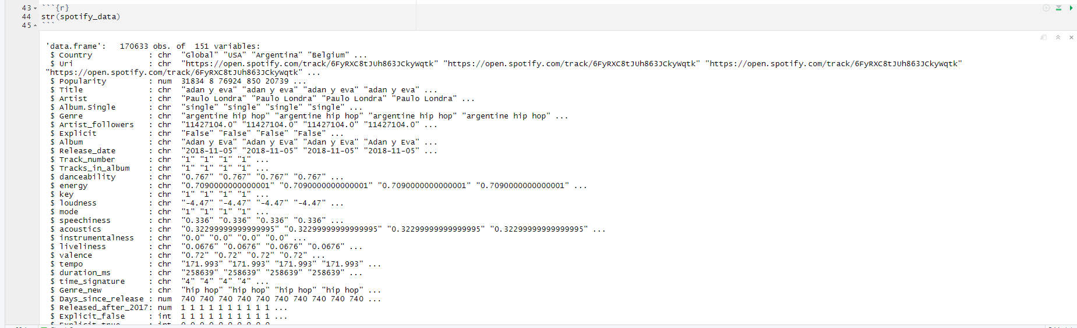

9.Summarising the data

summary(spotify_data)

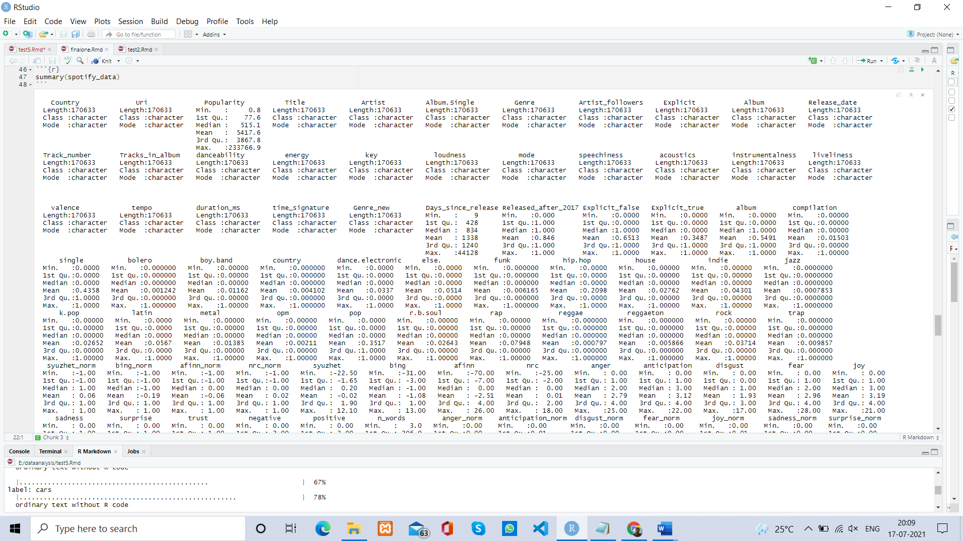

10.Displaying Dimension of the data

dim(spotify_data)

11.Displaying length of Genre column

length(spotify_data$Genre)

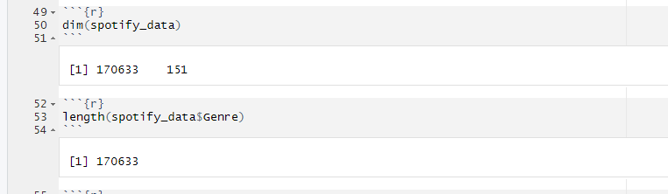

12.Displaying column names of data

colnames(spotify_data)

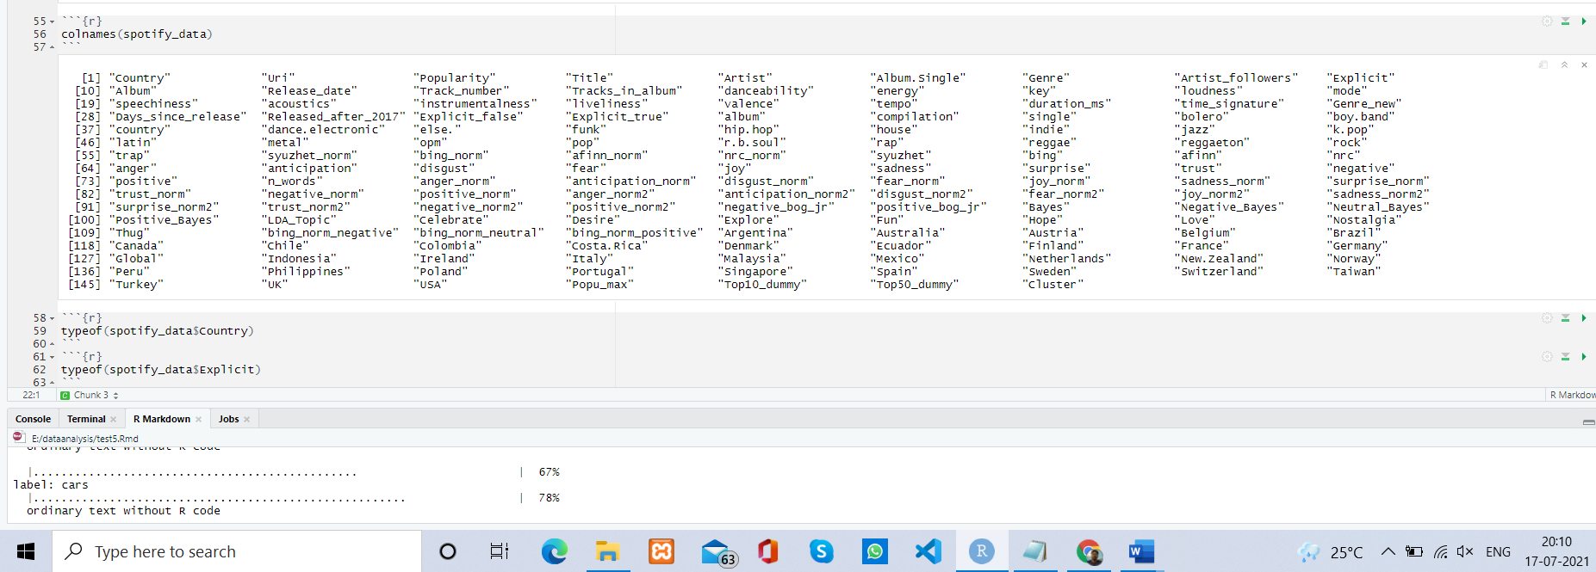

13.Displaying structure of some columns in the data

class(spotify_data$Name) typeof(spotify_data$Name)

14.Displaying type of some data structure in the data

typeof(spotify_data$Explicit)

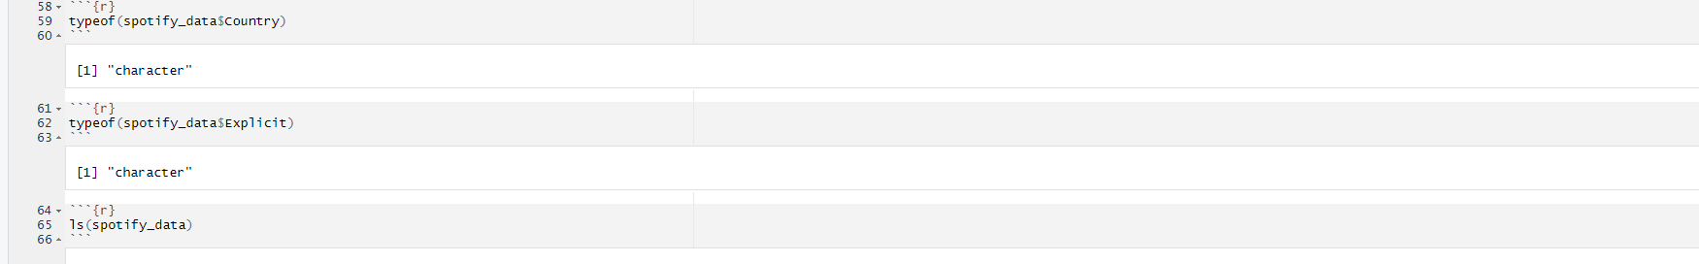

15.List of variables present in Spotify data ls(spotify_data)



16.Some pattern matching operations on variable of spotify_data

ls(spotify_data,pattern="^Sp")

ls(spotify_data,pattern="^[AD]")

ls(spotify_data,pattern="t.l")

ls(spotify_data,pattern="ce$")

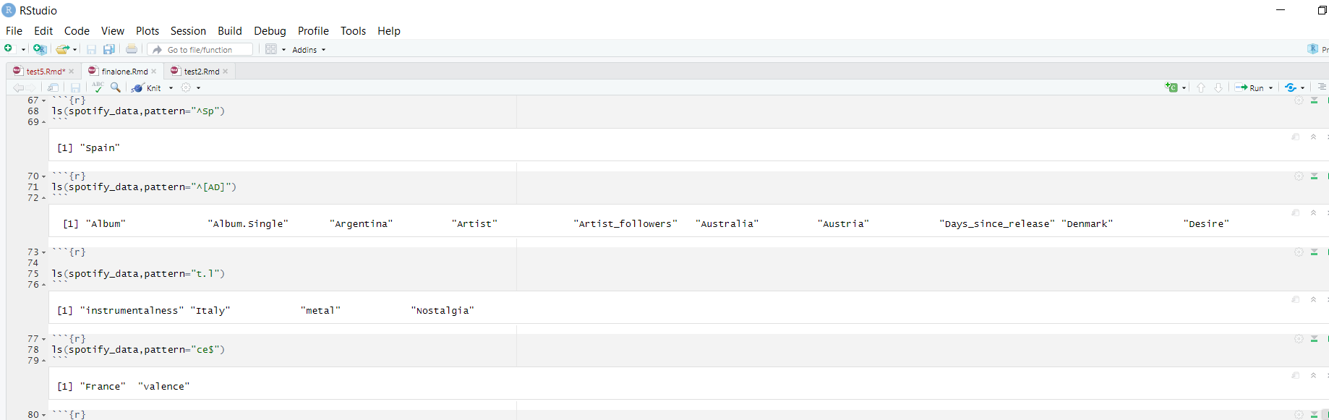

17.Display 1st row and all columns of data frame spotify_data[1,]

18.Display all rows and 1st column of data frame

spotify_data[,1]

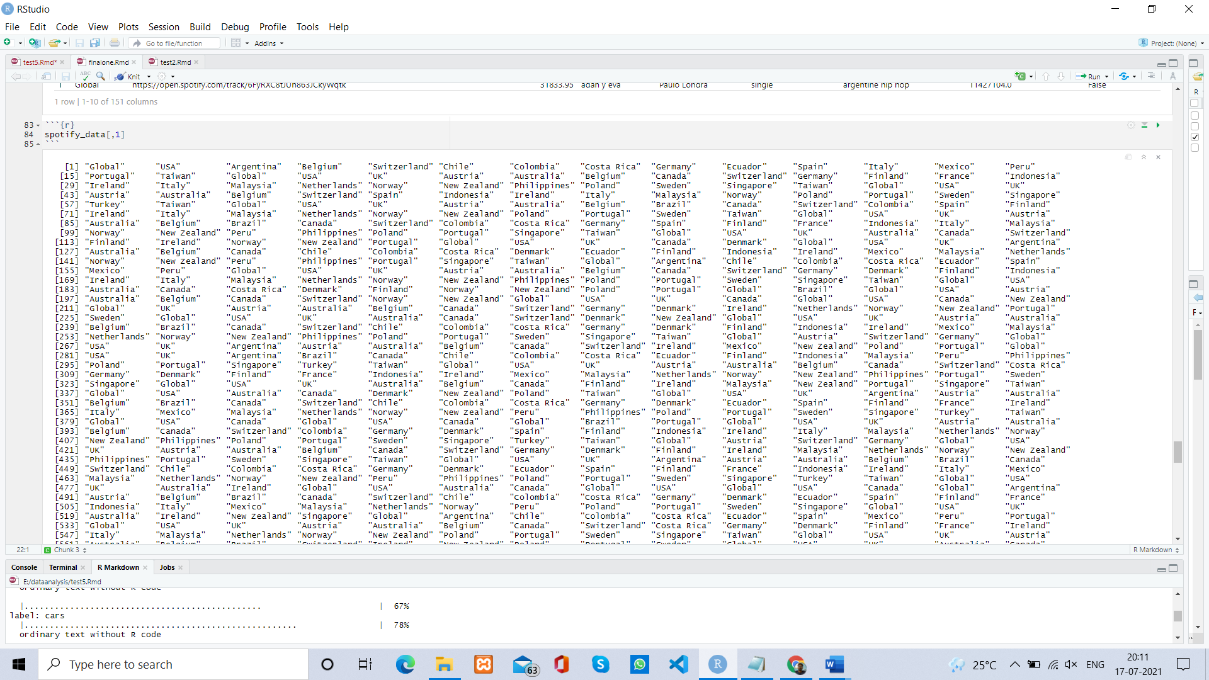

19.Display data in 2nd row and 3rd column of the data frame

spotify_data[2,3]

20.Display 1st and 2nd row and all columns spotify_data[1:2,]

21.Display all rows and first 3 columns

spotify_data[,3]

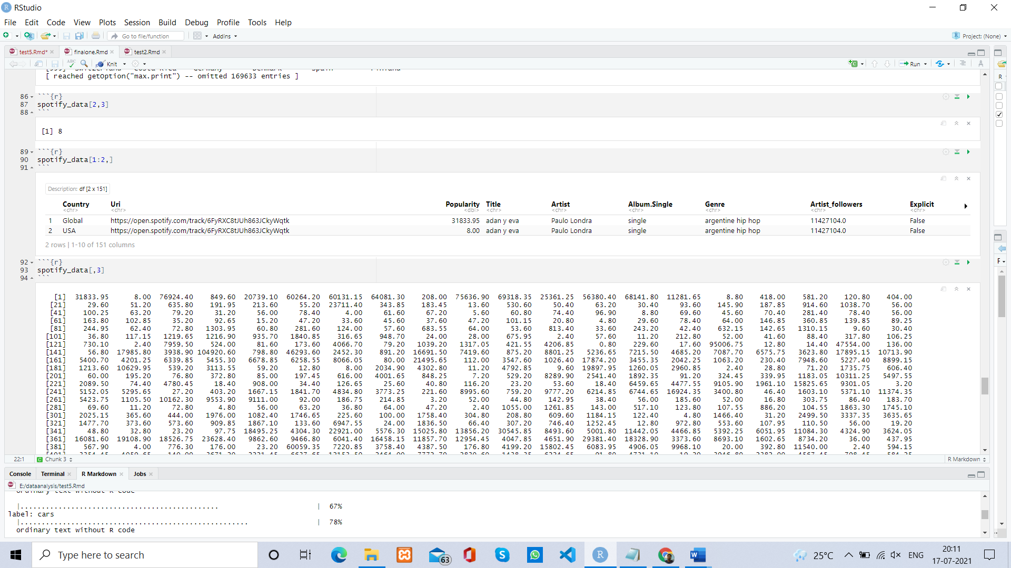

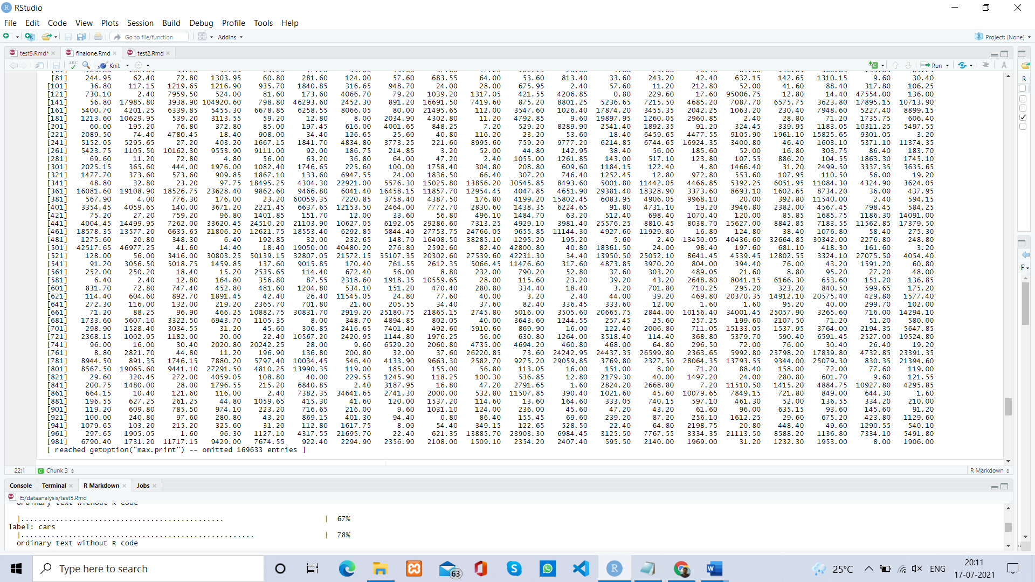

22.Selecting data where spotify name is Singapore with subset operator

temp_data=subset(spotify_data,Country=="Singapore")

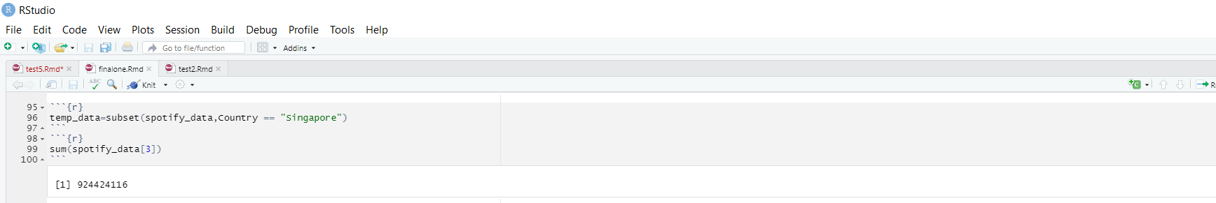

23.Renaming a column in data frame temp_spotify=spotify_datanames(temp_data)[names(temp_spotify)=="Total"]<-"Total_Number") temp_spotify[1,]

24.Adding a new column to dataframe temp_spotify[["New_col"]]<-rep(c(1,2,3,4,5),209) temp_spotify[1:10,]

25.Display Sum of Popularity column sum(spotify_data[3])

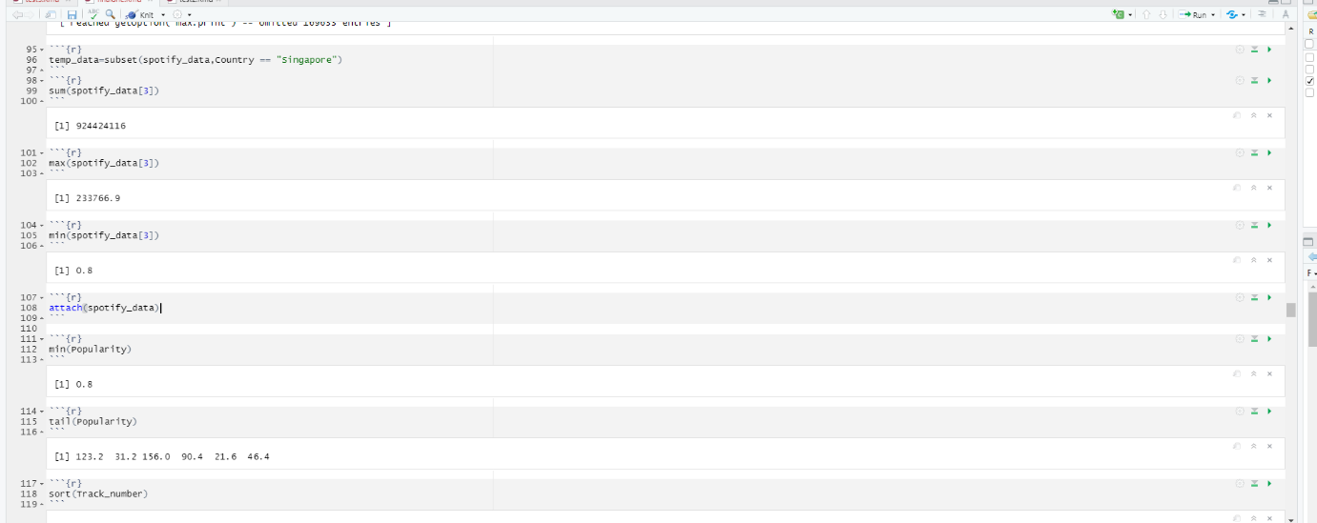

26.Display the maximum value of the Popularity column

max(spotify_data[3])

27.Display the minimum value of the Popularity column

min(spotify_data[3])

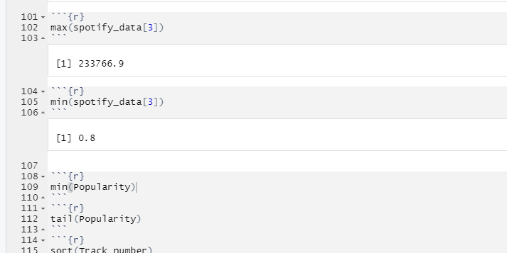

28.Attaching spotify data

attach(spotify_data)

29.Now we can use variables inside spotify data min(Popularity)

tail (Popularity)

30.Sorting Track_number variable in ascending order

sort(Track_number)

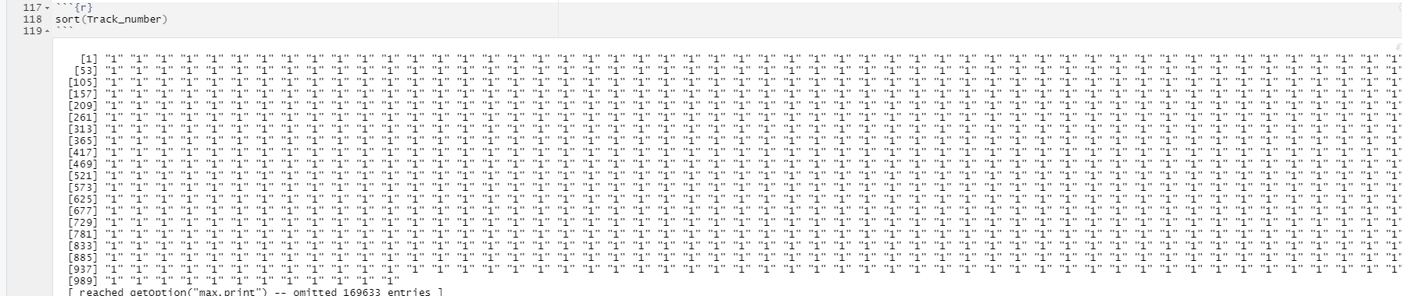

31.Sorting Track number variable in descending order

sort(Track_number,decreasing = TRUE)

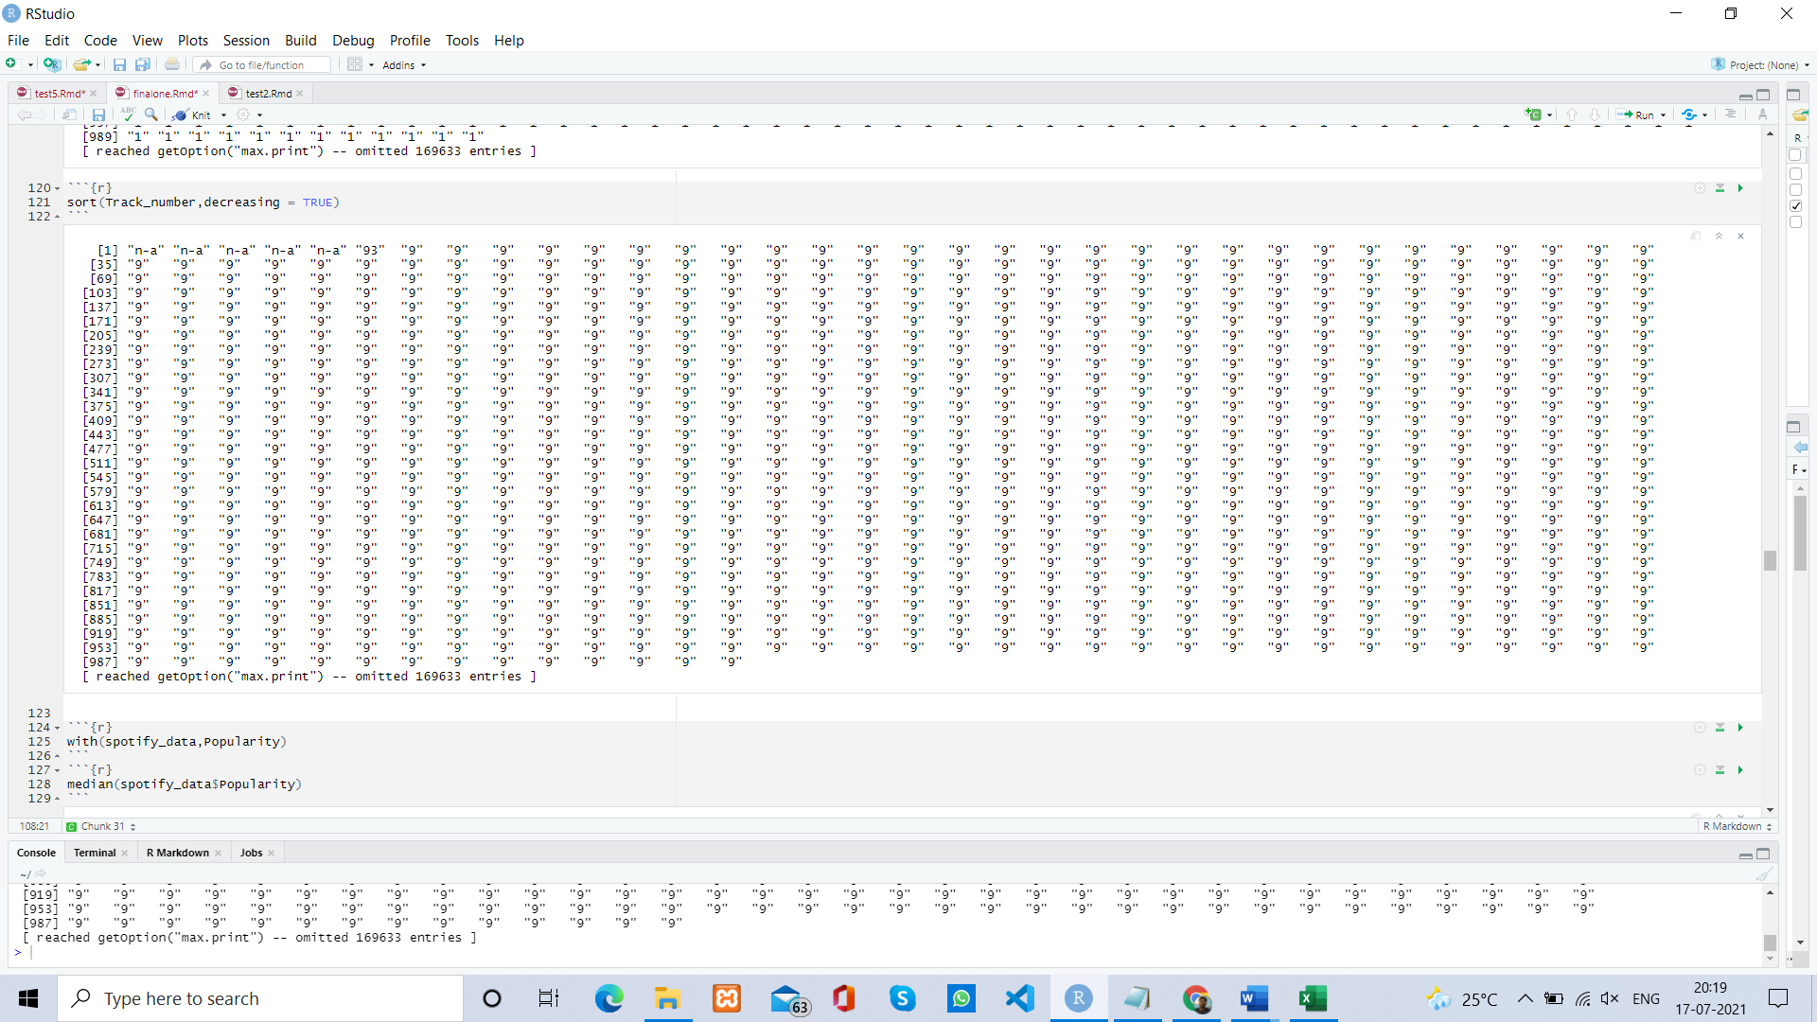

32.Detaching spotify data

detach(spotify_data)

33.Using with operator to use variables inside data

with(spotify_data,Popularity)

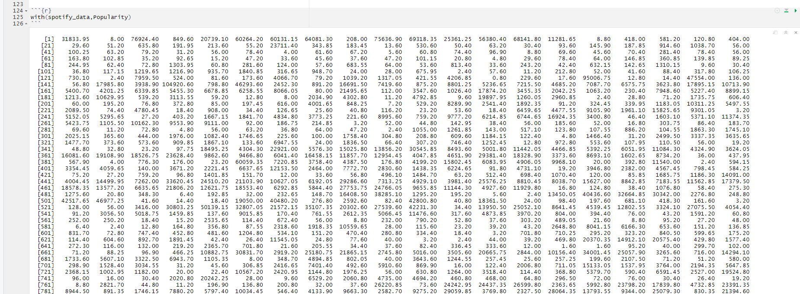

34.Finding median of data median(spotify_data$ Popularity)

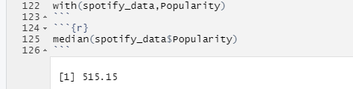

35.Finding mean of data mean(spotify_data$Popularity)

36.Finding standard deviation of data sd(spotify_data$ Popularity)

37.Finding variance of data var(spotify_data$ Popularity)

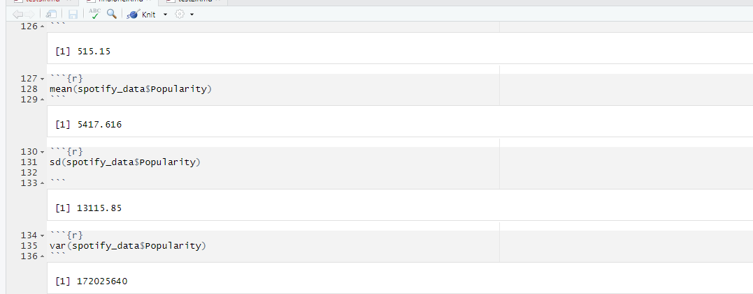

38.Order the Attack column in ascending order order(spotify_data[3])

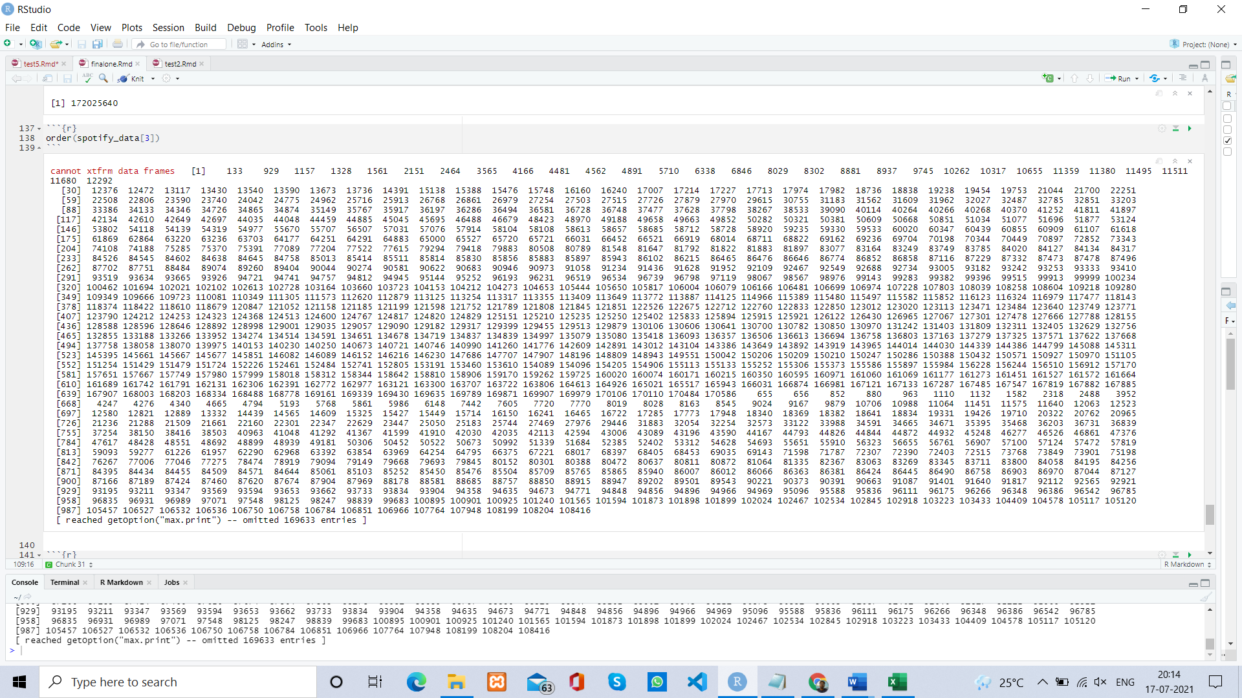

39.Order the Popularity column in descending order order(spotify_data$Poplarity,decreasing =TRUE)

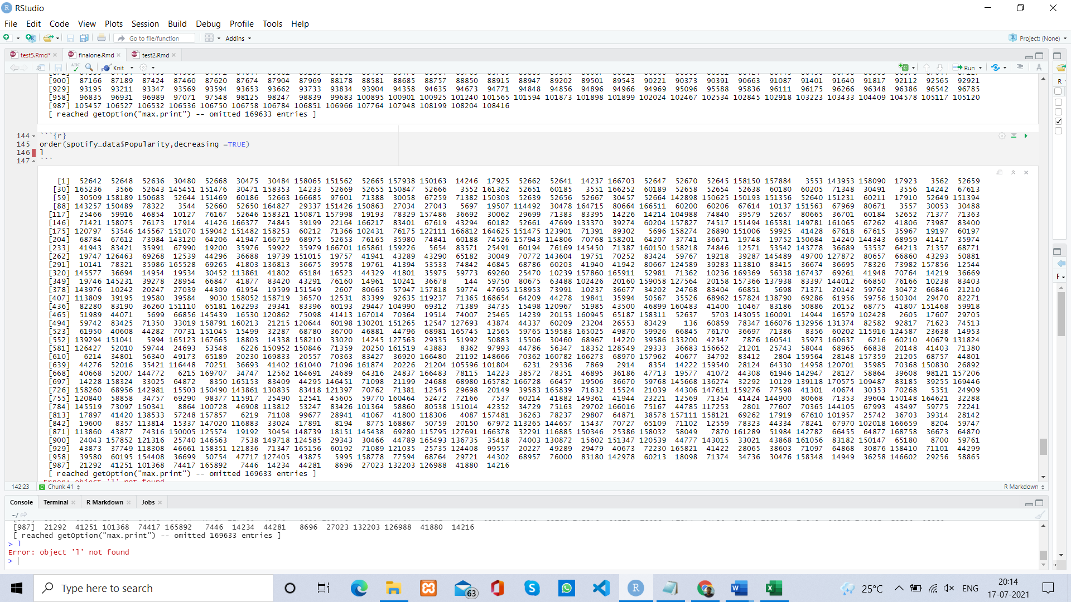

40.Rank of Speed column rank(spotify_data$Track_number)

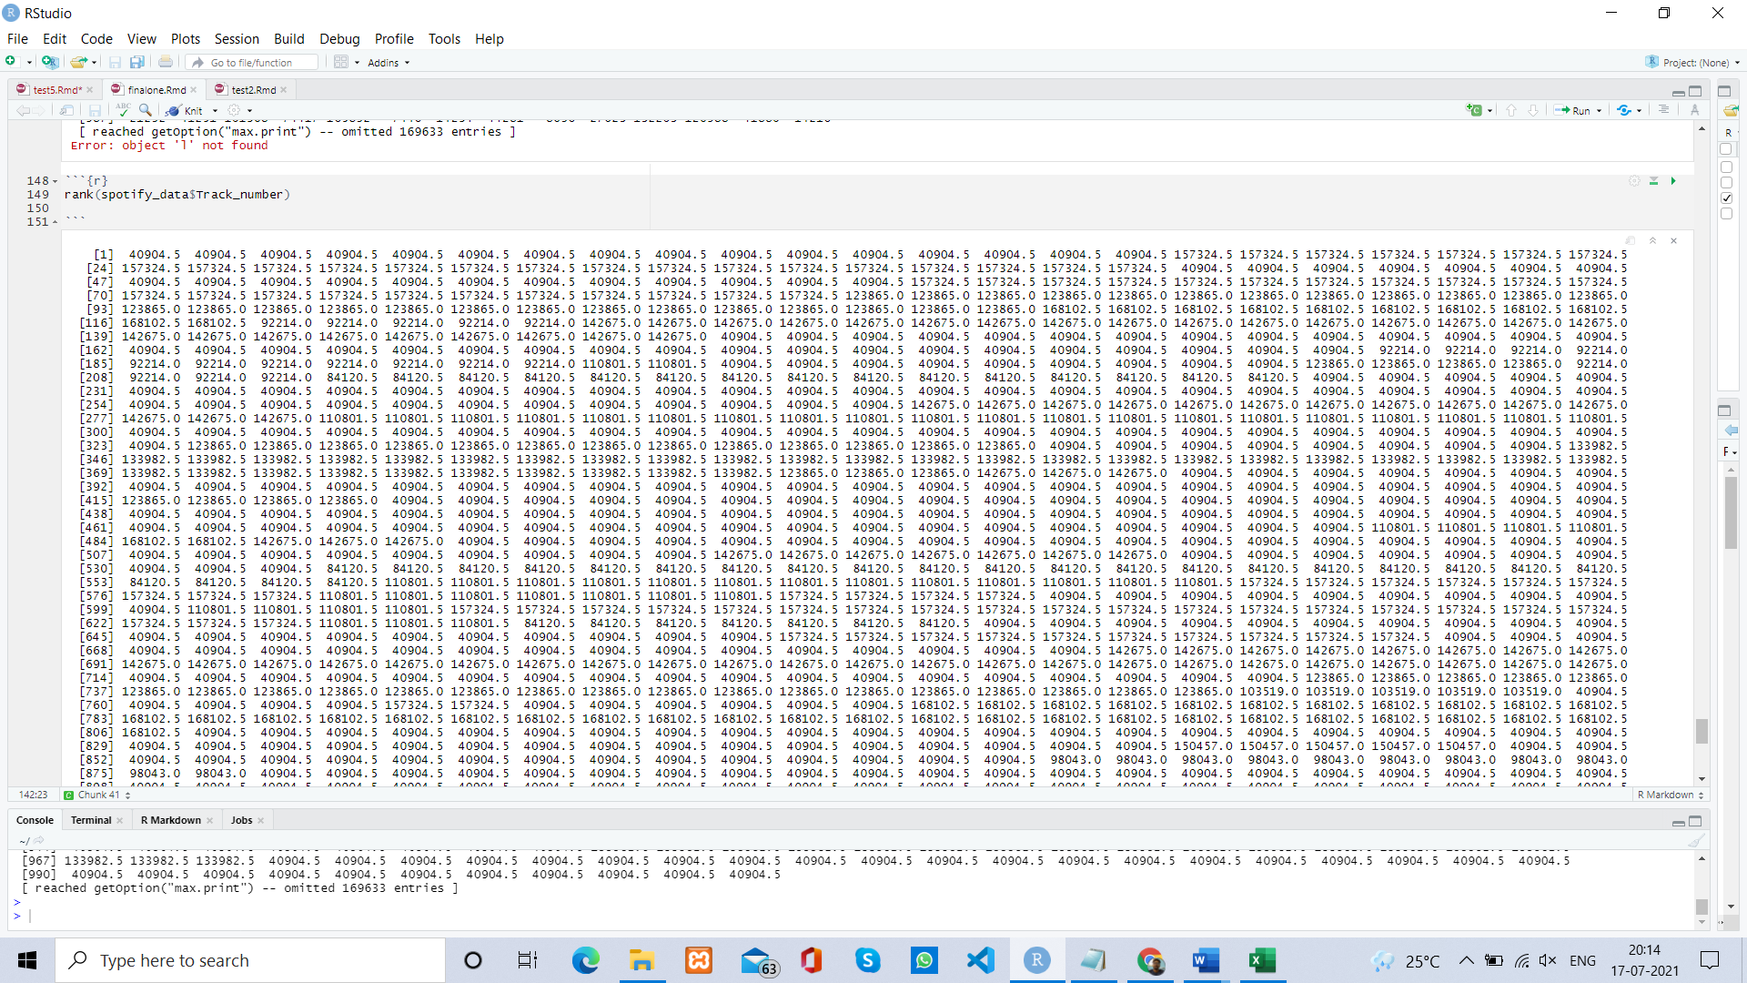

41.Rank of speed column with average as tie breaker rank(spotify_data$ Track_number,ties.method = "average")

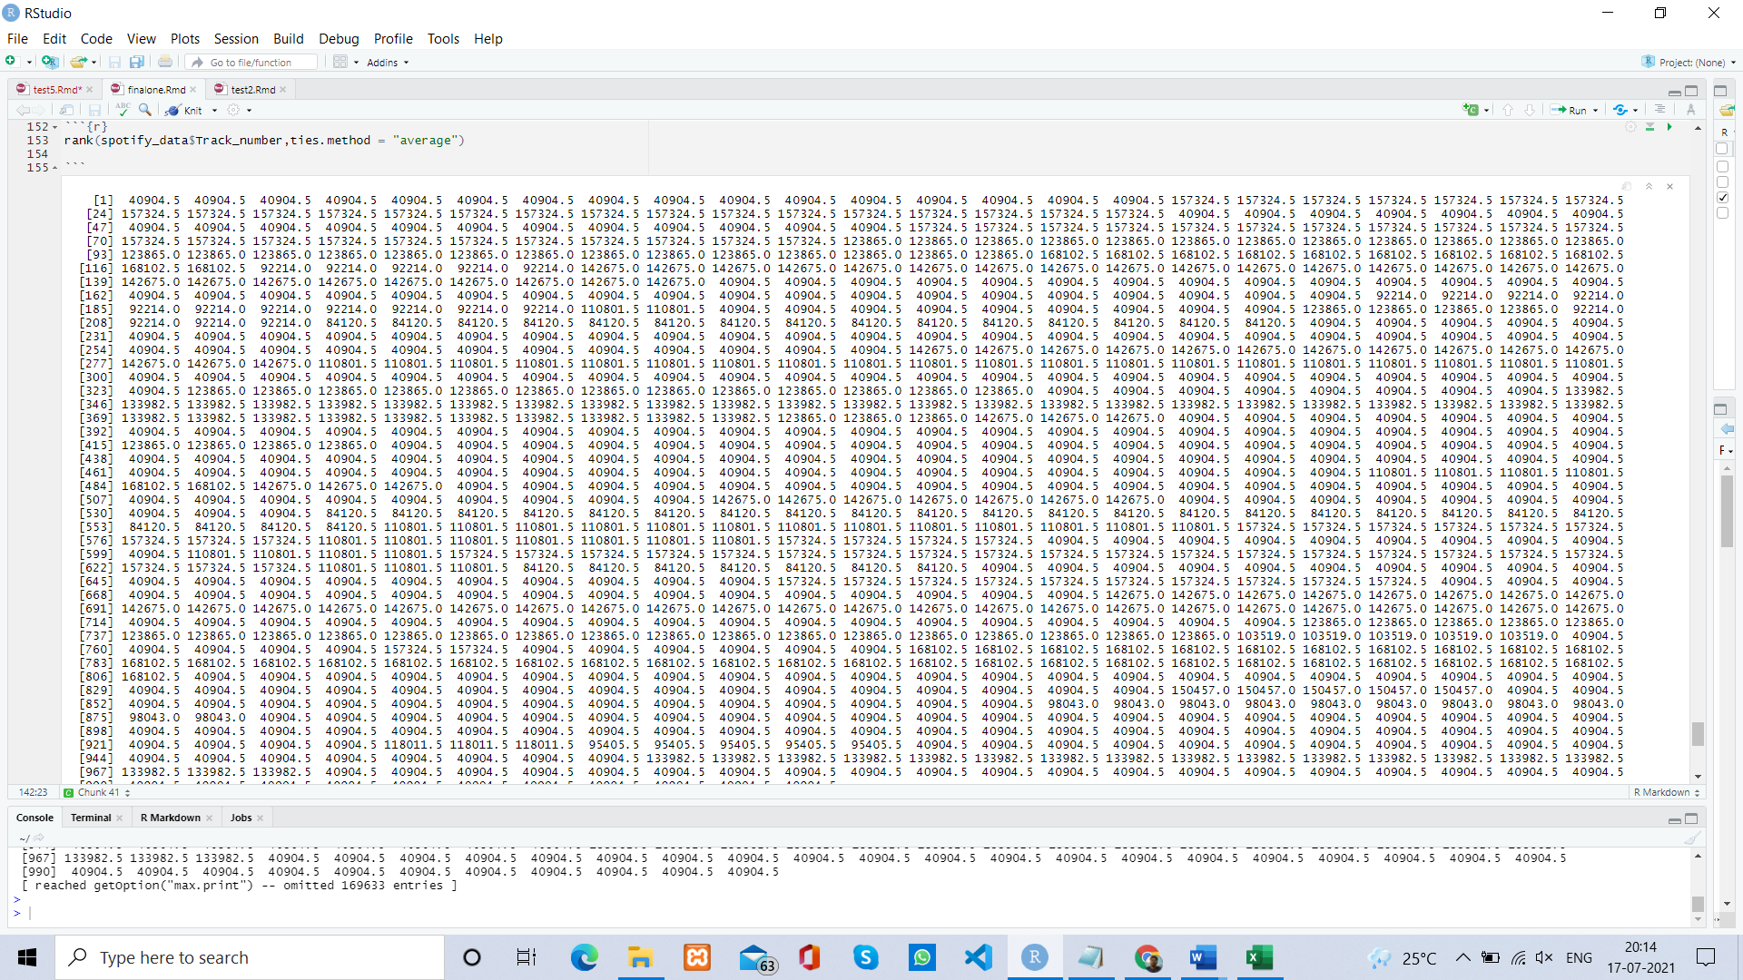

DPLYR operations

42.Usage of mutate function library(dplyr) Attaching package: 'dplyr'

head(spotify_data %>%mutate(mutated_Popularity=Popularity-mean(Popularity)))

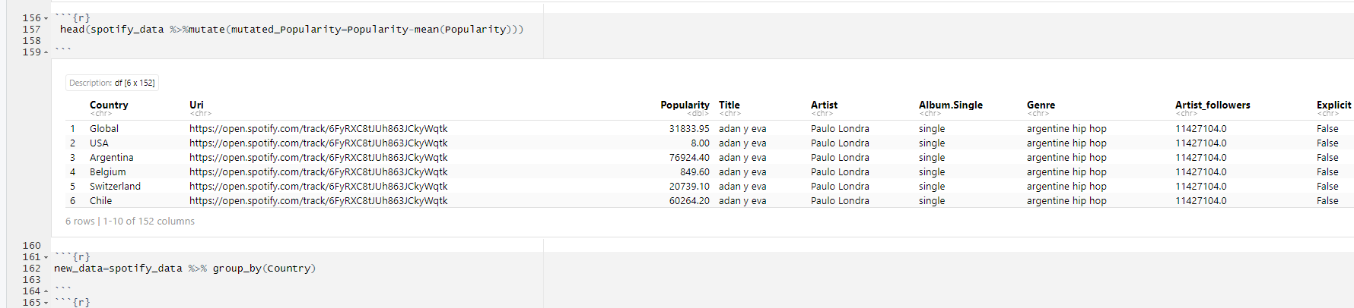

43.Adding extra column with user created vector vec = rep(c(1,2,3,4,5),209) head(spotify_data %>% mutate(newcol = vec))

44.Group by function new_data=spotify_data %>% group_by (Country)

head(new_data)

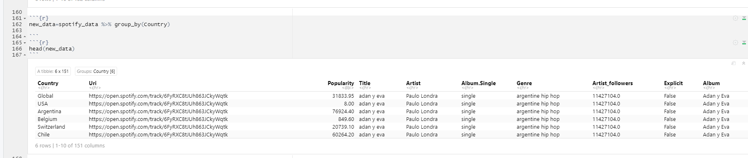

45.Histogram ggplot(spotify_data, aes(x = Popularity)) +geom_histogram()

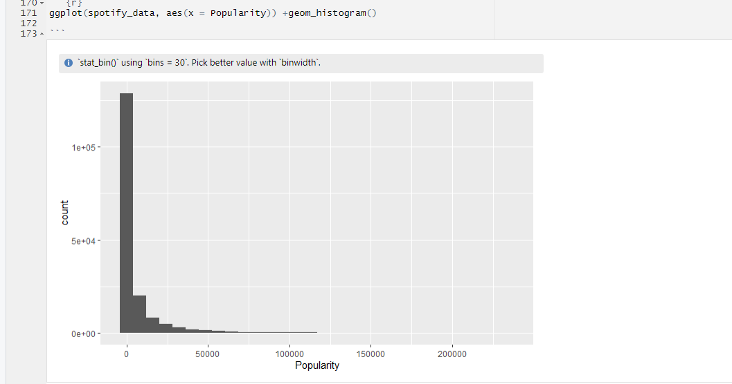

46.Histogram of Popularity column and its density ggplot(spotify_data,aes(x=Popularity))+ geom_histogram(fill="cornsilk",color="blue", size=0.2)+geom_density(color="black")

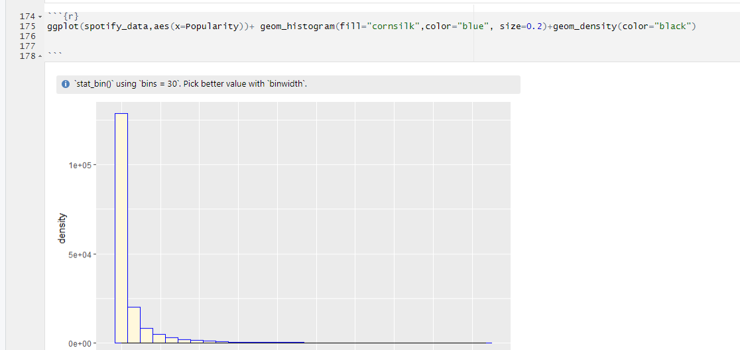

47.Line graph of Popularity column and its density ggplot(spotify_data,aes(x=Popularity))+ geom_density(fill="blue",alpha=.4)

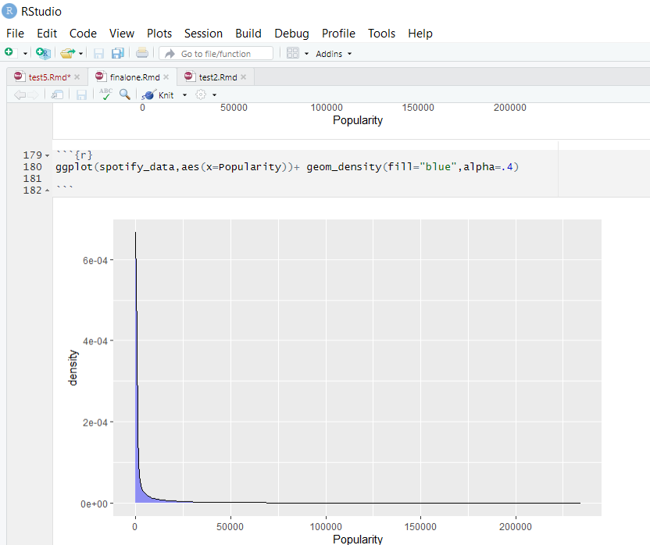

48.Line graph of Popularity column taking two alpha values ggplot(spotify_data,aes(x=Popularity))+ geom_line(stat="density")+ geom_line(stat="density",adjust=0.25, color="brown")+geom_density(fill='blue',alpha=0.2)

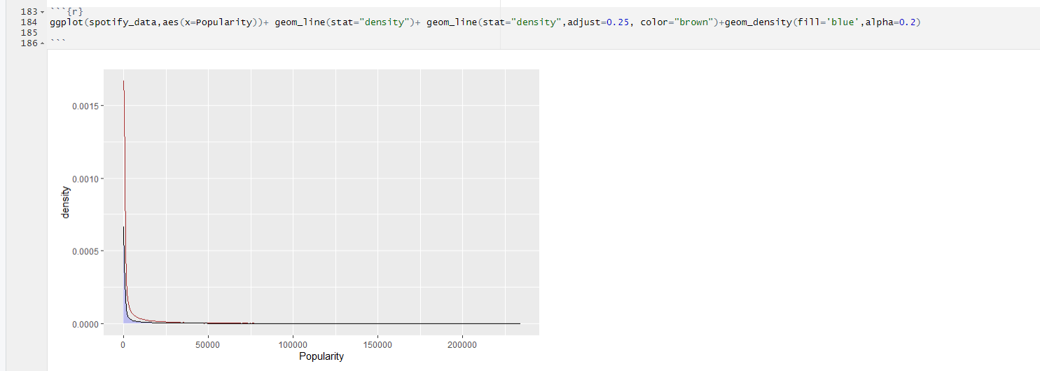

49.Dot Plot library(ggplot2) ggplot(spotify_data,aes(x=Popularity,y=Track_number))+geom_dotplot(binaxis="y",stackdir = "center", binwidth = 4,fill="green")

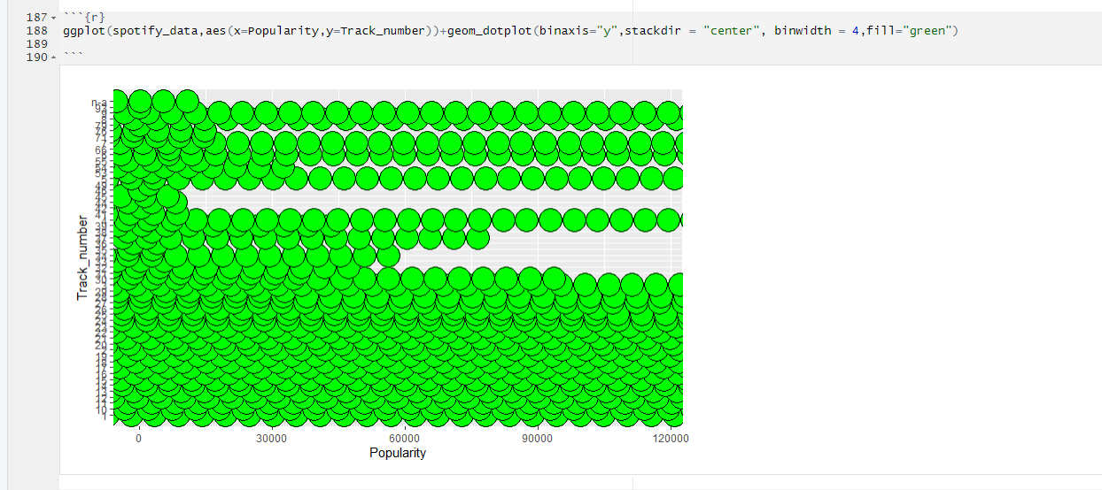

50.Box Plot ggplot(spotify_data, aes(x=Popularity,y=Track_number))+geom_boxplot(width=0.1,fill='black')

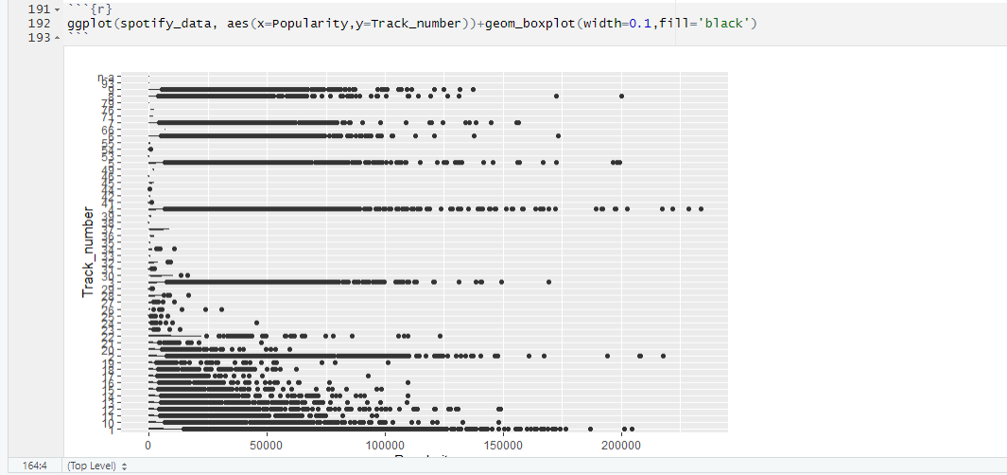

51.Violin Plot Attack and HP ggplot(spotify_data,aes(x=Popularity,y=Track_number))+geom_violin()

